1.Introduction:

i)Overview:

A vehicle that can be powered by an electric motor that draws electricity from a battery and is capable of being charged from an external source and have an electric motor instead of an internal combustion engine.

The Electric Vehicle (EV) is not new, but it has been receiving significantly more attention in recent years. Advances in both EV analytics and battery technologies have led to increased automotive market share. However, this growth is not attributed to hardware alone. The modern mechatronic vehicle marries electrical storage and propulsion systems with electronic sensors, controls, and actuators, integrated closely with software, secure data transfer, and data analysis, to form a comprehensive transportation solution. Advances in all these areas have contributed to the overall rise of EV’s, but the common thread that runs through all these elements is data analytics.

ii) purpose:

The new EV’s are combined Electrical storage and propulsion systems with electronic sensors, controls, and actuators, integrated closely with software, secure data transfer to form a comprehensive transportation solution.

2.problem destination and design thinking:

EMPATHY MAP:

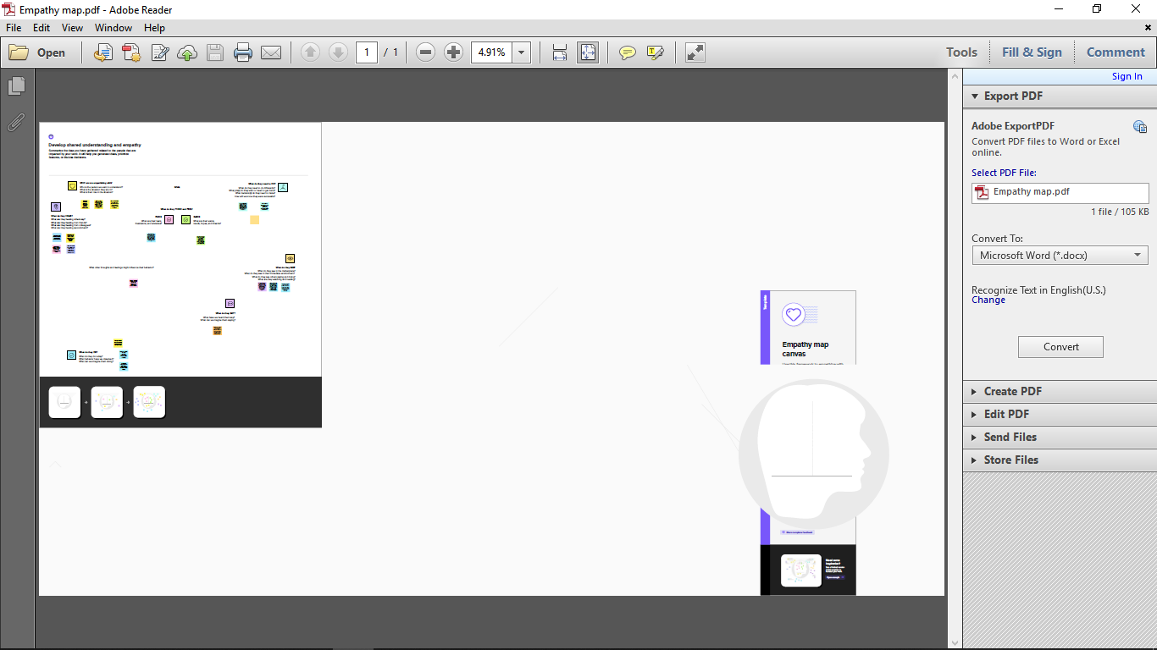



3.Result:

Dashboard

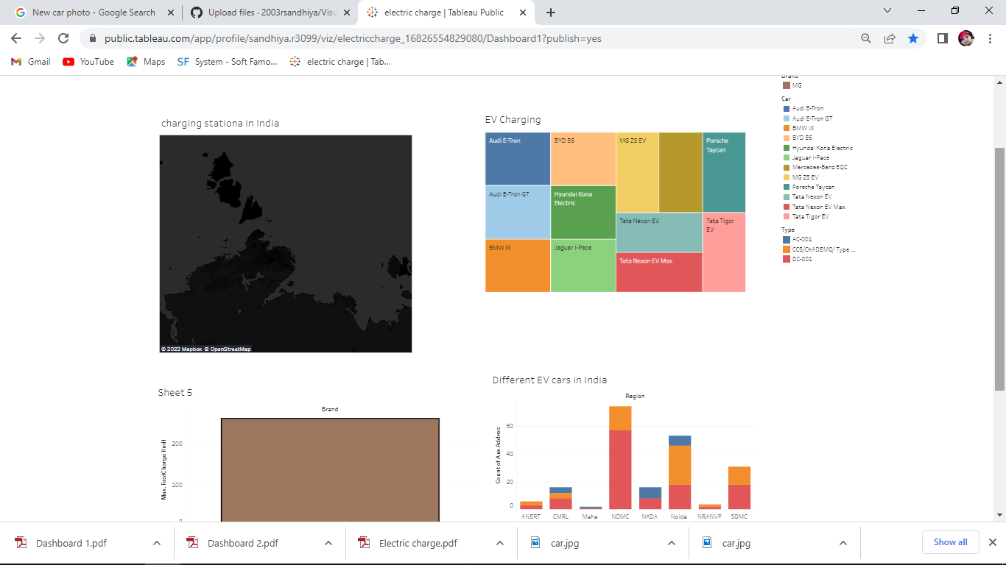

Story

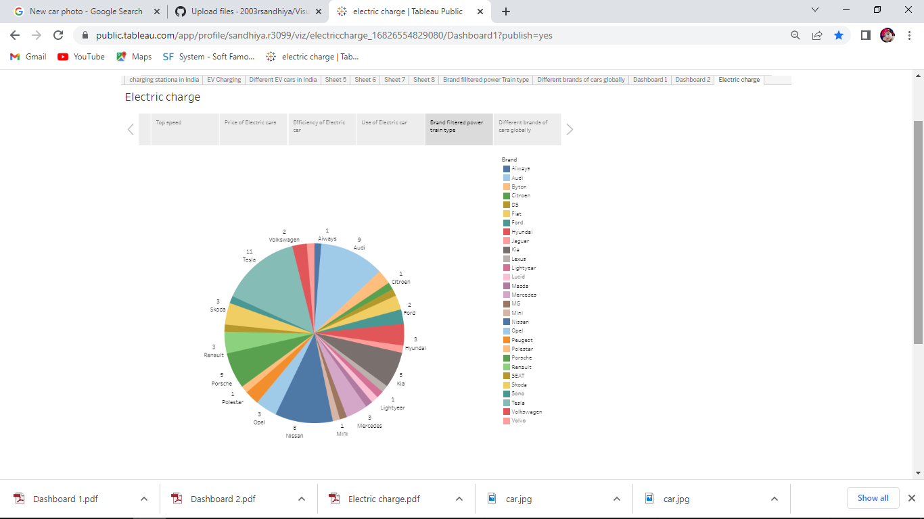

4.Advantages:

**Benefits Of Buying Electric Vehicles In India**

* Environmentally friendly. This is one of the main benefits of electric cars.
* Avoid the fuel price hikes.
* Low Maintenance Costs.
* Charge conveniently from the comfort of your home.
* Easy to drive.
* They make no noise.
* Government incentives

5.Disadvantages:

**Disadvantages of electric cars**

* Electric cars can travel less distance. AEVs on average have a shorter range than gas-powered cars. ...
* Electric cars can take a long time to recharge. Fueling an all-electric car can also be an issue. ...
* Electric cars can be expensive.

6.Applications:

An EV charger is a piece of equipment th

at supplies power for electric vehicles. Its main job is to recharge the battery of an EV to keep the vehicle in motion.

7.conclusion:

Currently, electric batteries are not the most popular choice for a battery nor are they anywhere near being the most common used in cars on the road. However, as they continue to get more efficient, cheaper, and easier to dispose of, they can become the most common car battery in our world.